## **Tech Research:**

**Misc / unknown:**

[Bingit.io](http://Bingit.io/) search engine

**Virtualization:**

**Network+:**

Cloud computing

BGP: border gateway protocol

TCPs three way handshake: syn synack ack

502 - Web server received an invalid response while acting as a gateway or proxy server.

There is a problem with the page you are looking for, and it cannot be displayed. When the Web server (while acting as a gateway or proxy) contacted the upstream content server, it received an invalid response from the content server.

PXE boot needs a boot server

**Programming:**

Organize your quotes doc and create an app that randomly selects a different quote each morning

Machine learning

High temp and low temp searches

What is ISDN PRI?: Primary Rate Interface

In the US we have a T1

* 24 channels: 23 voice (beta) channels and 1 delta channel

Internationally we have a E1

* 31 channels: 30 voice (beta) channels and 1 delta channel

Delta channels are used to set up at take down calls, and deliver name and number information

Advantages of PRI: reduced cost. Provides a circuit chart, multiple phone lines on one PRI circuit

ISDN is a digital version of traditional analog PSTN. PSTN was designed for analog phone calls

With digital data transmission, voice data remained the same. For computers, modems were developed to allow digital exchanges over existing analog PSTN networks. Digital signals are modulated to analog signals and transmitted over the PSTN network, then remodeulated when they arrive.

Analog signal disadvantages compared to digital signals:

1. Over the long distance, analog signals cannot maintain high quality
2. Analog signals carry less information per second than digital signals
3. Analog signals are not so flexible as digital signals in terms of data rate service and support

This is why ISDN was created. ISDN is a set of international communication standards designed in the 1980s and improved in the 1990s. It is a digital network to transmit voice, image, video and text over the existing circuit-switched PSTN telephone network

Two ISD options: Basic Rate Interface (BRI) and Primary Rate Interface (PRI)

DID (Direct Inward Dialing): individual phone line assigned to a particular user

DOD (Direct Outward Dialing): used for a call center

Call hunting. Asequential, desequantial

The PRI card is inside the PBX

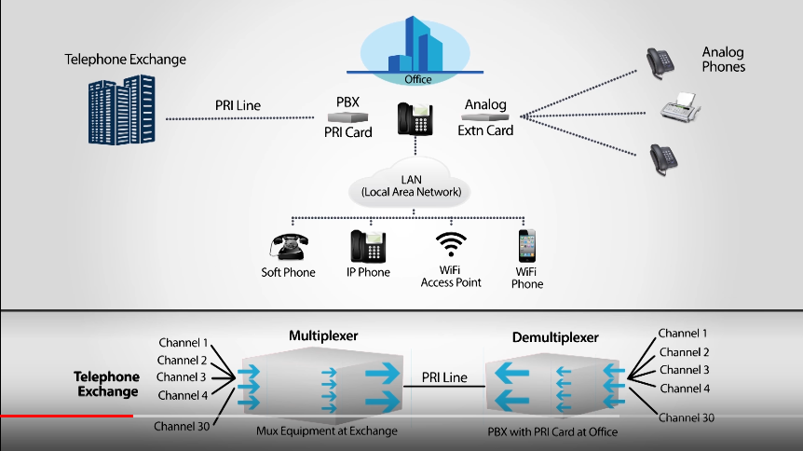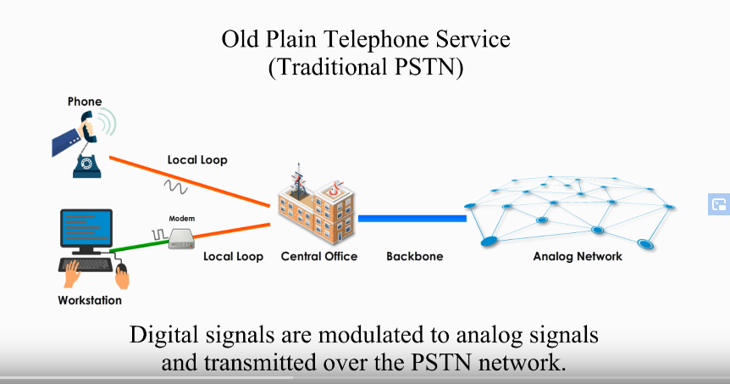

**Tasks / To-Do / Projects:**

Organize the A+ document

setup ipv6 after flashing router

Archive.org (there are two archiving services. One is run by the government and the other isn’t)

**Research topics:**

Electronic frontier foundation (EFF)

what is windows sharepoint

AP Computer Science Principles (exam by the college board)

Open source alternative to discord

Mastodon social media

<https://www.reddit.com/r/degoogle/>

Research the digital nomad lifestyle

Other tech related subreddits

Tech links in 4chan boards

What is AS/400 Used For? AS/400 architecture is often used for ERP and other mission-critical tasks, particularly in industries that require extreme reliability, such as manufacturing. IBM Power Systems are popular with SAP users, as well as competing database management systems, such as Oracle Database.

<https://en.m.wikipedia.org/wiki/IBM_i>

IBM Power Systems

Windows/SQL

Linux/Oracle

Research different forms of input and an input method that is superior to the keyboard

DOS is an old OS: MS-DOS and IBM PC DOS

Software configuration management systems: perforce, concurrent version system, Microsoft visual source safe, ibm rational

Windows Preinstallation environment (WinPE)

Windows assessment and deployment kit (ADK)

ZAP: Zscaler application profiler

How do email servers actually work?

<https://packetlife.net/blog/>

Research the history of IT

**Cybersecurity:**

Arp cache poisoning

Vx heaven (site for info on viruses)

Cybersecurity Projects:

Download old viruses into a VM and see what they do

Install custom firmware on your router (not modem) that can spoof MAC addresses. Very simple n00b technique to get a new IP address. Tomato is an older but very functional custom FW.

a cookie is a small file that a website stores on your computer

a tracking pixel stores information on your web server, a 1x1 transparent image that tracks how a user reacts to your web pages

Find when poking a website or server starts becoming suspicious. This really depends on the sensitivity of the security tracking software on the server you are investigating

2019 study from blancco and ontrack - Storage devices

DBAN darik's boot and nuke

Routerpasswords.com

KIOPTRIX VM IMAGE CHALLENGES:

This Kioptrix VM Image are easy challenges. The object of the game is to acquire root access via any means possible (except actually hacking the VM server or player). The purpose of these games are to learn the basic tools and techniques in vulnerability assessment and exploitation. There are more ways then one to successfully complete the challenges.

Windows came from MSDOS

Hackthebox.eu

Enumeration is the most important pentesting skill

Nikto

Burp suite

The difference between redteaming and pentesting

OSINT

TheHarvester

Bluto (using this will get you noticed on the network you target)

Crt.sh

Fingerprinting:

Wappalyzer

Whatweb

NMAP scan:

Nmap -T4 -p- <ip address>

Steal handshake / stealth scanning

Nmap scanning

Nessus home

Cybrary

Packet squirrel

SoC

ESN (similar to IMEI)

Wikipedia: hacking in the 90s

Phiber optik and acid freak

Certs:

eWPT, OSCP, OSWP, CEH, CCNA, Pentest+,

Token impersonation

Linux:

/etc/passwd

/etc/shadow

Sudoers file

Auth.log

systemctl

How to MiTM somebody:

Volunteer to be an exit node

ARP cache poisoning

Become an access point

room 641a

The nsa installing backdoors in to encryption algorithms

Symmetric encryption

Symmetric authentication

Private (public key) encryption

Private (public key) authentication

Heartbleed 2014 attack

302 redirect

Ssl strip

HSTS

3d Printing

Cloudflare: hosting without censorship

Ethan Zuckerman

Or at least he might gain a tool to monitor the number and location of infected machines, a move that malware analysts call “sinkholing.”

**Electrical engineering:**

Application specific integrated circuit (ASIC)

Extended Display Identification Data (EDID) is a metadata format for display devices to describe their capabilities to a video source (e.g. graphics card or set-top box). The data format is defined by a standard published by the Video Electronics Standards Association (VESA).

Silicone carbide in computer hardware

What are modchips? Modchip central website

Processor-dependent and processor-independent code

Flat virtual memory called single-level store

Hardware abstraction

Inductive charging

**Low level programming:**

What are pipe commands?:

allows you to pass the output of one cmdlet to the input of another cmdlet

Machine interface code (MI) or Microcode

Technology independent machine interface (TIMI)

System licensed internal code (SLIC) / kernel

Kornshell, bourne shell, C shell

Binary code compatibility

Source code compatibility

**Tech conferences:**

MARS is a yearly event hosted by Amazon Founder and CEO Jeff Bezos. MARS brings together innovative minds in Machine learning, Automation, Robotics, and Space to share new ideas across these rapidly advancing domains.

***Wolfram:***

<https://www.wolfram.com/>

<https://www.wolfram.com/technologies/>

<https://www.wolfram.com/language/>

<https://writings.stephenwolfram.com/category/computational-thinking/>

<https://writings.stephenwolfram.com/2012/03/the-personal-analytics-of-my-life/>

<https://www.christopherwolfram.com/>

<https://writings.stephenwolfram.com/2016/04/my-life-in-technology-as-told-at-the-computer-history-museum/>

A new kind of science book: <https://www.wolframscience.com/nks/>

<https://www.stephenwolfram.com/publications/>

<https://www.wolframalpha.com/>

https://resources.wolframcloud.com/FunctionRepository

https://demonstrations.wolfram.com/

**Mobile:**

Proprietary Driver binaries

<https://developers.google.com/android/drivers>

Open source android OS:

<https://replicant.us/>

<https://replicant.us/supported-devices.php>

<https://microg.org/>

<https://lineage.microg.org/>

Degoogling your phone will require buying an old android phone that’s supported

You can’t use email, or youtube on your phone if you degoogle your phone

You can’t play music unless it’s locally downloaded

Mobile phone logs:

Apple: xcode

Android: logcat

**Digital Writing:**

If a tech service is free, you’re the product.

**Math / statistics:**

Tableau reporting

Girdles theorem

Lambda calculus

Computational representations

**Social Media:**

Growing Instagram (quotesconnoisseur): Take the ideas you've jotted down, and plug them into Instagram's search bar as hashtags. From there, you'll see which ones are most popular on Instagram--prioritize them accordingly. Grow your list of hashtags through “Related Items”

**Programming:**

Software performance testing

Memory protection: Abstraction and arbitration

OS must ensure that a process cannot access memory that does not belong to it

Segmentation

valid/invalid pages

**Memory Stack:**

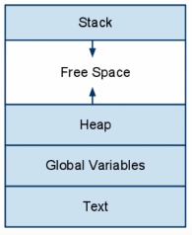

**Windows Commands:**

<https://www.howtogeek.com/163127/how-powershell-differs-from-the-windows-command-prompt/>

<https://www.howtogeek.com/126265/how-to-troubleshoot-internet-connection-problems/>

<https://www.howtogeek.com/111859/how-to-batch-rename-files-in-windows-4-ways-to-rename-multiple-files/>

<https://www.howtogeek.com/138121/geek-school-learning-powershell-objects/>

<https://www.howtogeek.com/114344/5-cmdlets-to-get-you-started-with-powershell/>

<https://www.howtogeek.com/138121/geek-school-learning-powershell-objects/>

Shell commands?:

* Grep
* Awk

What does curl do?

What is the system registry?  
What are cmdlets in powershell?  
WMI (Windows Management Instrumentation)

write a script to automate various system administration tasks with powershell